**Arrays**

**import java.util.*;**

**class Array1**

**{**

**public static void main(String args[])**

**{**

**int[] arr=new int[5];**

**int i;**

**Scanner sc=new Scanner(System.in);**

**//Reading**

**System.out.println("Enter the ele into array");**

**for(i=0;i<5;i++)**

**{**

**arr[i]=sc.nextInt();**

**}**

**//printing**

**System.out.println("Elements in an array :");**

**for(i=0;i<5;i++)**

**{**

**System.out.print(arr[i]+"\t");**

**}**

**}**

**}**

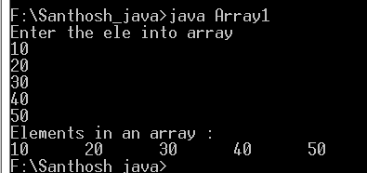

**Initialization:**

*class Array1*

*{*

*public static void main(String args[])*

*{*

*int[] arr={10,20,30,40,50};*

*int i;*

*//printing*

*System.out.println("Elements in an array :");*

*for(i=0;i<5;i++)*

*{*

*System.out.print(arr[i]+"\t");*

*}*

*}*

*}*

**

class Array1

{

public static void main(String args[])

{

int[] arr={10,20};

int i;

//printing

System.out.println("Elements in an array :");

for(i=0;i<arr.length;i++)

{

System.out.print(arr[i]+"\t");

}

}

}

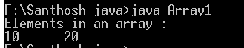

**Example**

import java.util.*;

class Array1

{

public static void main(String args[])

{

int n;

Scanner sc=new Scanner(System.in);

System.out.println("Enter the array size");

n=sc.nextInt();

int[] arr=new int[n];

System.out.println("Elements Plz :");

int i;

for(i=0;i<n;i++)

{

arr[i]=sc.nextInt();

System.out.println("Next ele Y/N");

String str=sc.next();

if(str.equals("N"))

break;

}

//printing

System.out.println("Elements in an array :");

for(int j=0;j<=i;j++)

{

System.out.print(arr[j]+"\t");

}

}

}

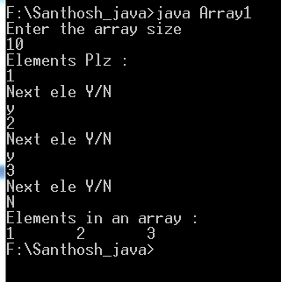

Command line arguments

class Demo

{

public static void main(String args[])

{

for(String str:args)

System.out.println(str);

}

}

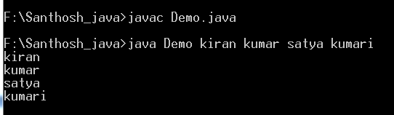

**Example 2:**

class Demo

{

public static void main(String args[])

{

int num1,num2;

num1=Integer.parseInt(args[0]);

num2=Integer.parseInt(args[1]);

System.out.println("Addition is "+(num1+num2));

}

}

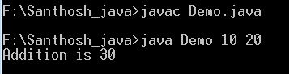

**Jagged Array:**

import java.util.*;

class Demo

{

public static void main(String args[])

{

int[][] arr=new int[3][];

arr[0]=new int[1];

arr[1]=new int[2];

arr[2]=new int[3];

//Reading elements

System.out.println("Enter elements");

Scanner sc=new Scanner(System.in);

int i,j;

for(i=0;i<3;i++)

{

for(j=0;j<arr[i].length;j++)

{

arr[i][j]=sc.nextInt();

}

}

System.out.println("________________________");

System.out.println("Elements in an array");

System.out.println("________________________");

for(i=0;i<3;i++)

{

for(j=0;j<arr[i].length;j++)

{

System.out.print(arr[i][j]+"\t");

}

System.out.println();

}

}

}

